SIMATS ENGINEERING
ASSESSMENT TOOL 2

COURSE NAME:Design and Analysis of Algorithms
COURSE CODE: CSA06

COURSE OUTCOME COVERED

CO3: Design Divide and Conquer algorithms for Merge Sort, Quick Sort, Binary Search and Matrix Multiplication (BL4, BL5)

Annexure A

Case Study

Q21. Case Study: Cloud Data Sorting System (Merge Sort)
A cloud-based system must sort massive datasets distributed across multiple servers to support analytics and reporting. Analyze how Merge Sort can be applied efficiently in this distributed environment. Identify key issues such as scalability, data partitioning, and stability. Apply divide and conquer techniques to explain how sorting is performed across nodes. Analyze time complexity and design a solution, justifying why Merge Sort is suitable for cloud-based systems.

Problem Statement:
A cloud-based system must sort massive datasets distributed across multiple servers to support analytics and reporting. Analyze how Merge Sort can be applied efficiently in this distributed environment. Identify key issues such as scalability, data partitioning, and stability. Apply divide and conquer techniques to explain how sorting is performed across nodes. Analyze time complexity and design a solution, justifying why Merge Sort is suitable for cloud-based systems.

Aim:
To analyze the implementation of Merge Sort in a cloud-based distributed system and explain how Divide and Conquer improves sorting efficiency for large datasets.

Understanding of the Case:
Cloud computing systems process huge amounts of data every day. A single server cannot efficiently sort such a large volume of information. Therefore, the dataset is divided into smaller parts and distributed among multiple cloud servers. Each server independently sorts its assigned partition using Merge Sort. Finally, all sorted partitions are merged to produce one completely sorted dataset. This approach improves performance, scalability, and reliability.

Key Issues:
- Processing very large datasets.
- Scalability across multiple cloud servers.
- Efficient data partitioning.
- Stable sorting of records.
- Communication between cloud nodes.
- Load balancing among distributed systems.

Application of Divide and Conquer:
Merge Sort follows the Divide and Conquer strategy.
- Divide the dataset into smaller partitions.
- Assign each partition to different cloud servers.
- Each server independently sorts its partition.
- Merge all sorted partitions.
- Produce one globally sorted dataset.
This parallel execution reduces processing time and increases efficiency.

Analysis:
Merge Sort provides consistent performance in all cases.
Case | Time Complexity
Best Case | O(n log n)
Average Case | O(n log n)
Worst Case | O(n log n)
Space Complexity | O(n)
Because Merge Sort is a stable sorting algorithm, duplicate records maintain their original order after sorting. This makes it suitable for cloud-based analytics systems.

Solution Design:
The proposed cloud-based solution consists of the following steps:
- Split the large dataset into multiple partitions.
- Store each partition on different cloud servers.
- Execute Merge Sort independently on every server.
- Merge the sorted partitions using the merge process.
- Return the final sorted dataset for reporting and analytics.
This solution supports distributed processing and improves system performance.

Justification:
Merge Sort is suitable for cloud environments because:
- It is a stable sorting algorithm.
- It provides predictable O(n log n) performance.
- It naturally supports parallel execution.
- It efficiently handles massive datasets.
- It improves scalability in distributed systems.

Advantages:
- High scalability.
- Stable sorting.
- Efficient for large datasets.
- Suitable for distributed cloud computing.
- Consistent execution time.

Applications:
- Cloud Data Analytics
- Big Data Processing
- Banking Systems
- E-Commerce Platforms
- Scientific Computing
- Data Warehousing

Conclusion:
Merge Sort is one of the most suitable algorithms for cloud-based data sorting because it efficiently handles massive datasets using the Divide and Conquer approach. Its stability, predictable time complexity, and ability to perform parallel processing make it highly effective for cloud analytics and reporting systems.

Source code:

#include <stdio.h>
#include <stdlib.h>
#include <pthread.h>
#include <time.h>

#define SIZE 100000

int arr[SIZE];

typedef struct {
int left;
int right;
} ThreadData;

void merge(int left, int mid, int right) {
int n1 = mid - left + 1;
int n2 = right - mid;

int *L = (int *)malloc(n1 * sizeof(int));
int *R = (int *)malloc(n2 * sizeof(int));

for (int i = 0; i < n1; i++)
L[i] = arr[left + i];

for (int j = 0; j < n2; j++)
R[j] = arr[mid + 1 + j];

int i = 0, j = 0, k = left;

while (i < n1 && j < n2) {
if (L[i] <= R[j])
arr[k++] = L[i++];
else
arr[k++] = R[j++];
}

while (i < n1)
arr[k++] = L[i++];

while (j < n2)
arr[k++] = R[j++];

free(L);
free(R);
}

void mergeSort(int left, int right) {
if (left < right) {
int mid = (left + right) / 2;

mergeSort(left, mid);
mergeSort(mid + 1, right);
merge(left, mid, right);
}
}

void *threadMergeSort(void *arg) {
ThreadData *data = (ThreadData *)arg;
mergeSort(data->left, data->right);
return NULL;
}

int main() {
srand(time(NULL));

for (int i = 0; i < SIZE; i++)
arr[i] = rand() % 100000;

ThreadData t1 = {0, SIZE / 2 - 1};
ThreadData t2 = {SIZE / 2, SIZE - 1};

pthread_t thread1, thread2;

clock_t start = clock();

pthread_create(&thread1, NULL, threadMergeSort, &t1);
pthread_create(&thread2, NULL, threadMergeSort, &t2);

pthread_join(thread1, NULL);
pthread_join(thread2, NULL);

merge(0, SIZE / 2 - 1, SIZE - 1);

clock_t end = clock();

double time_taken = (double)(end - start) / CLOCKS_PER_SEC;

printf("Parallel Merge Sort Completed Successfully.\n");
printf("Execution Time: %.6f seconds\n", time_taken);

return 0;
}
Output:
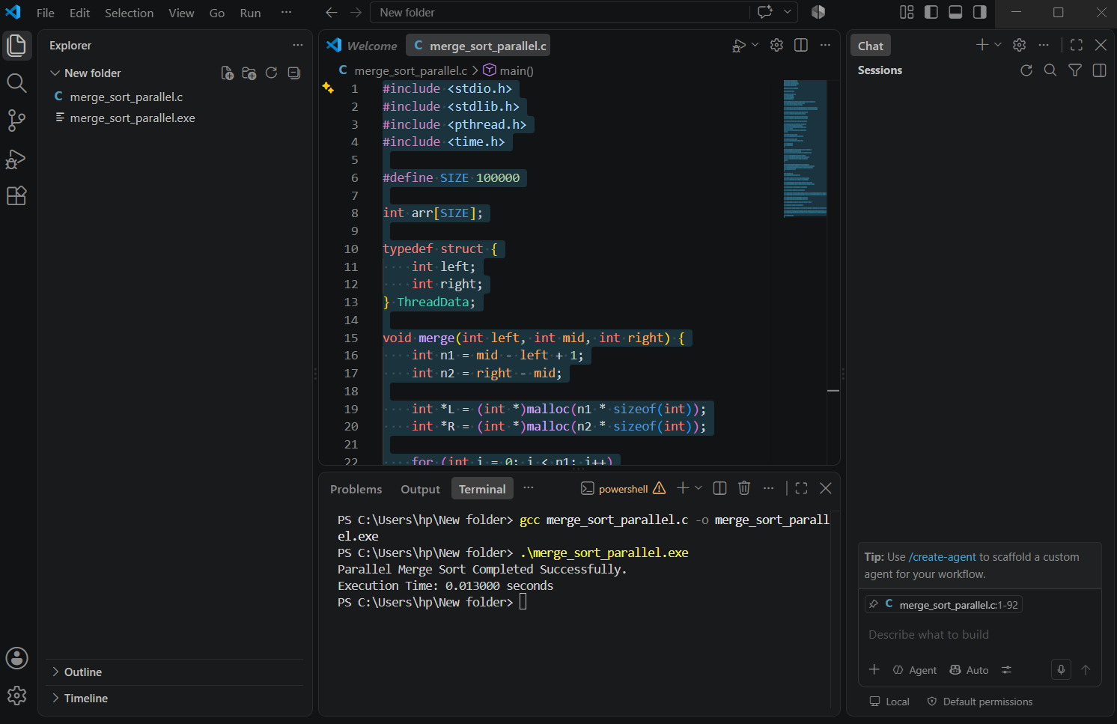

RUBRICS FOR CALCULATION:
Case Study
Criteria | Weightage | Level 4 – Exemplary | Level 3 – Proficient | Level 2 – Developing | Level 1 – Beginning
Understanding of Case | 25 | Thorough understanding; clearly identifies all key issues | Good understanding with most issues identified | Basic understanding; some issues missed | Poor understanding; problem not identified correctly
Application of Concepts | 25 | Effectively applies relevant concepts to analyze the case deeply | Applies appropriate concepts with minor gaps | Limited application of concepts | Fails to apply relevant concepts
Analysis | 20 | In-depth analysis with strong reasoning and insights | Good analysis with logical reasoning | Basic analysis with limited depth | Weak or no analysis; lacks reasoning
Solution Design | 20 | Innovative, feasible solutions with strong justification | Logical solutions with adequate justification | Basic solutions with weak justification | Incorrect or no solution provided
Clarity | 10 | Clear, well-structured, and easy to understand | Organized and understandable presentation | Limited clarity and structure | Poor clarity; difficult to understand

